Part1 Selenium assessment_ Gayathri Peri

Scenario - 1:

Launch the opencart application in firefox browser using "demo.opencart.com" url. Validate whether the application has been invoked correctly

Code:

//Scenario - 1:

//Launch the opencart application in firefox browser using "demo.opencart.com" url.

//Validate whether the application has been invoked corectly

**package** assg;

**import** org.junit.Test;

**import** org.junit.Before;

**import** org.junit.After;

**import** **static** org.junit.Assert.*;

**import** **static** org.hamcrest.CoreMatchers.*is*;

**import** **static** org.hamcrest.core.IsNot.*not*;

**import** org.openqa.selenium.By;

**import** org.openqa.selenium.WebDriver;

**import** org.openqa.selenium.firefox.FirefoxDriver;

**import** org.openqa.selenium.Dimension;

**import** org.openqa.selenium.WebElement;

**import** org.openqa.selenium.interactions.Actions;

**import** org.openqa.selenium.support.ui.ExpectedConditions;

**import** org.openqa.selenium.support.ui.Select;

**import** org.openqa.selenium.support.ui.WebDriverWait;

**import** org.openqa.selenium.JavascriptExecutor;

**import** org.openqa.selenium.Alert;

**import** org.openqa.selenium.Keys;

**public** **class** AppLaunch {

public static void main(String args[])

{

String s= "C:\\Users\\TRNG\\Downloads\\gecko\\geckodriver.exe";

WebDriver driver;

System.*setProperty*("webdriver.gecko.driver",s);

driver = **new** FirefoxDriver();

driver.get("https://demo.opencart.com/");

// scenario 1 : to check if launched application is correct one or not : APPLICATION VALIDATION

String x= driver.findElement(By.*xpath*("/html/body/header/div/div/div[1]/div/h1/a")).getText();

String y="Your Store";

**if**(x.equals(y))

{

System.***out***.println("application invoked successfully");

}

**else**

System.***out***.println("application not invoked successfully");

}

}

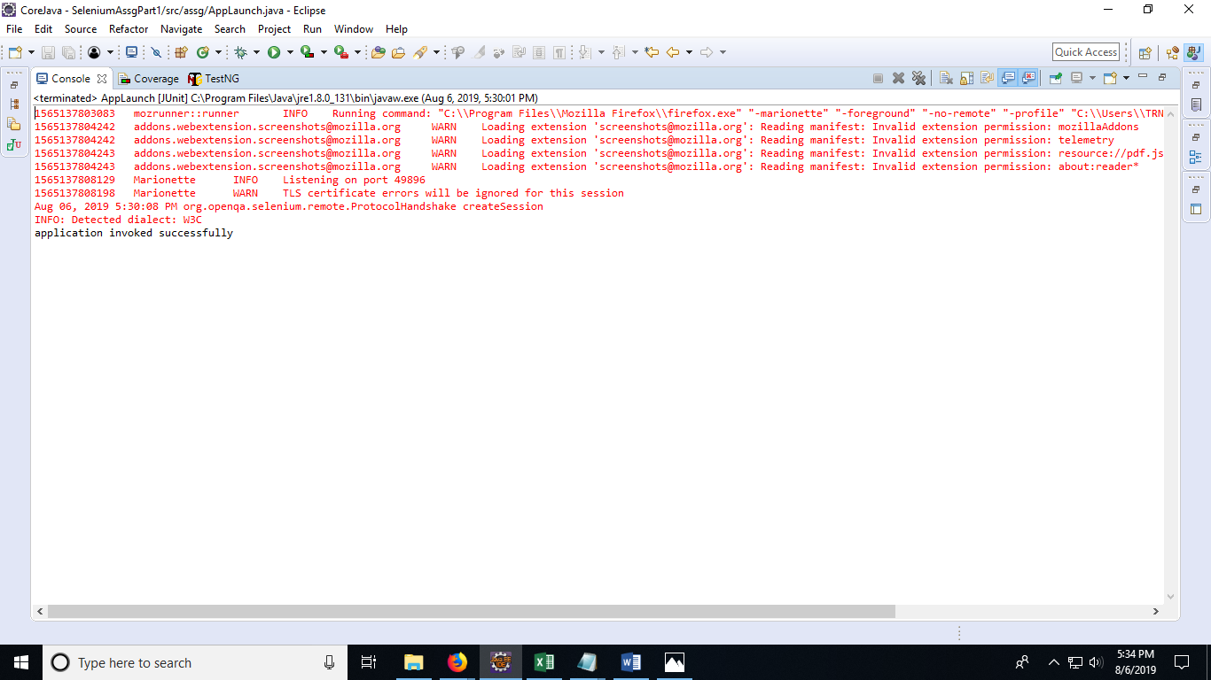

Scenario 1 output

Scenario - 2:

Count the number of images present in home page of opencart

Code:

//Scenario - 2:

//Count the number of images present in home page of opencart

**package** assg;

**import** org.junit.Test;

**import** org.junit.Before;

**import** org.junit.After;

**import** **static** org.junit.Assert.*;

**import** java.util.List;

**import** **static** org.hamcrest.CoreMatchers.*is*;

**import** **static** org.hamcrest.core.IsNot.*not*;

**import** org.openqa.selenium.By;

**import** org.openqa.selenium.WebDriver;

**import** org.openqa.selenium.firefox.FirefoxDriver;

**import** org.openqa.selenium.Dimension;

**import** org.openqa.selenium.WebElement;

**import** org.openqa.selenium.interactions.Actions;

**import** org.openqa.selenium.support.ui.ExpectedConditions;

**import** org.openqa.selenium.support.ui.Select;

**import** org.openqa.selenium.support.ui.WebDriverWait;

**import** org.openqa.selenium.JavascriptExecutor;

**import** org.openqa.selenium.Alert;

**import** org.openqa.selenium.Keys;

**public** **class** CountofImg {

public static void main(String args[])

{

String s= "C:\\Users\\TRNG\\Downloads\\gecko\\geckodriver.exe";

WebDriver driver;

System.*setProperty*("webdriver.gecko.driver",s);

driver = **new** FirefoxDriver();

driver.get("https://demo.opencart.com/");

List<WebElement> L=driver.findElements(By.*tagName*("img"));

System.***out***.println("Count of no.of images "+L.size());

}

}

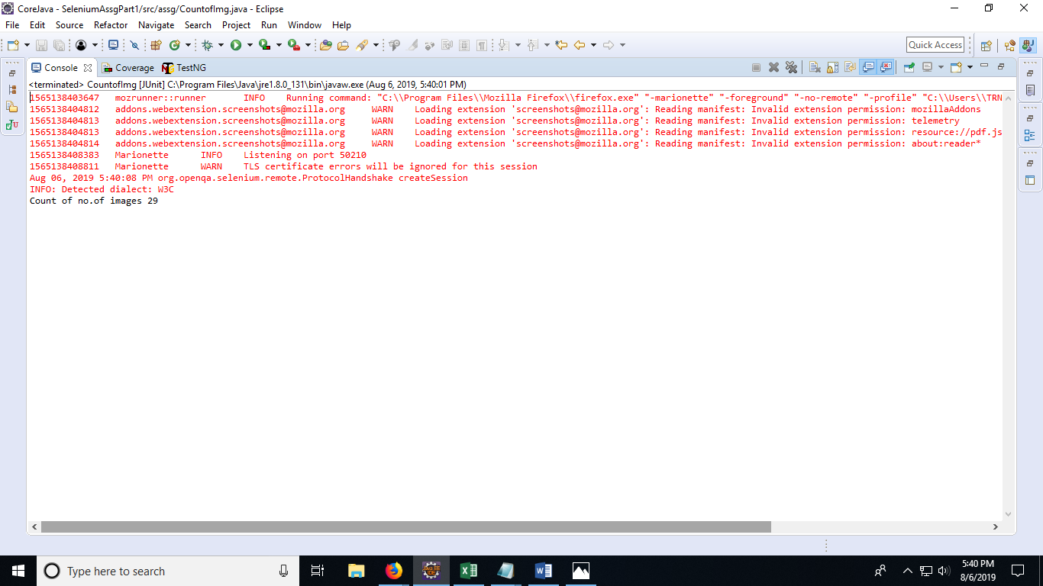

Scenario 2 output

Scenario - 3:

Check whether the given phno in home page is 9980519955

Code:

//Scenario - 3:

//Check whether the given phno in home page is 9980519955

**package** assg;

**import** java.util.List;

**import** **static** org.hamcrest.CoreMatchers.*is*;

**import** **static** org.hamcrest.core.IsNot.*not*;

**import** org.openqa.selenium.By;

**import** org.openqa.selenium.WebDriver;

**import** org.openqa.selenium.firefox.FirefoxDriver;

**import** org.openqa.selenium.Dimension;

**import** org.openqa.selenium.WebElement;

**import** org.openqa.selenium.interactions.Actions;

**import** org.openqa.selenium.support.ui.ExpectedConditions;

**import** org.openqa.selenium.support.ui.Select;

**import** org.openqa.selenium.support.ui.WebDriverWait;

**import** org.openqa.selenium.JavascriptExecutor;

**import** org.junit.Before;

**import** org.junit.Test;

**import** org.openqa.selenium.Alert;

**import** org.openqa.selenium.Keys;

**public** **class** Phoneno {

public static void main(String args[])

{

String s= "C:\\Users\\TRNG\\Downloads\\gecko\\geckodriver.exe";

WebDriver driver;

System.*setProperty*("webdriver.gecko.driver",s);

driver = **new** FirefoxDriver();

**public** **void** untitled() {

driver.get("https://demo.opencart.com/");

String str1=driver.findElement(By.*xpath*("/html/body/nav/div/div[2]/ul/li[1]/span")).getText();

String str2="9980519955";

**if**(str1.equals(str2))

{

System.***out***.println("Phone number is same");

}

**else**

System.***out***.println("Phone number not same. homepage number different from given number");

//driver.close();

}

}

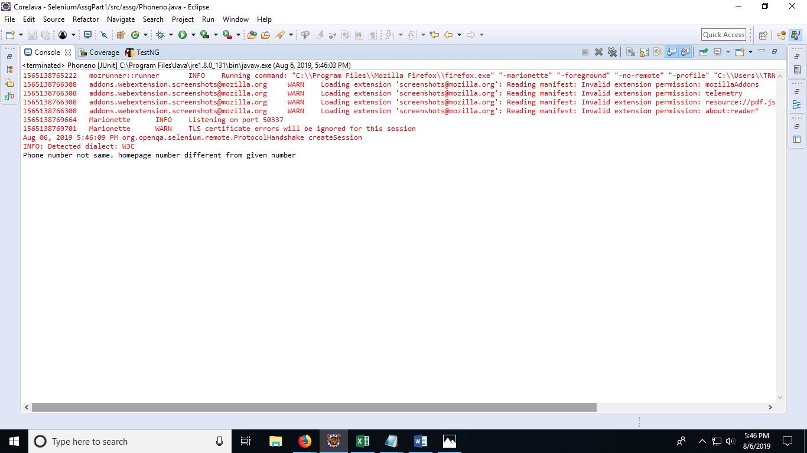

Scenario 3 output

Scenario - 4

Login pre req:

Desktop -> Show all desktop ->Extract the price of Apple cinema 30.

Check whether its less than $50.00// check if same or not

Code :

//Scenario - 3:

//Check whether the given phno in home page is 9980519955

**package** assg;

**import** java.util.List;

**import** **static** org.hamcrest.CoreMatchers.*is*;

**import** **static** org.hamcrest.core.IsNot.*not*;

**import** org.openqa.selenium.By;

**import** org.openqa.selenium.WebDriver;

**import** org.openqa.selenium.firefox.FirefoxDriver;

**import** org.openqa.selenium.Dimension;

**import** org.openqa.selenium.WebElement;

**import** org.openqa.selenium.interactions.Actions;

**import** org.openqa.selenium.support.ui.ExpectedConditions;

**import** org.openqa.selenium.support.ui.Select;

**import** org.openqa.selenium.support.ui.WebDriverWait;

**import** org.openqa.selenium.JavascriptExecutor;

**import** org.junit.Before;

**import** org.junit.Test;

**import** org.openqa.selenium.Alert;

**import** org.openqa.selenium.Keys;

**public** **class** Phoneno {

public static void main(String args[])

{

String s= "C:\\Users\\TRNG\\Downloads\\gecko\\geckodriver.exe";

WebDriver driver;

System.*setProperty*("webdriver.gecko.driver",s);

driver = **new** FirefoxDriver();

driver.get("https://demo.opencart.com/");

String str1=driver.findElement(By.*xpath*("/html/body/nav/div/div[2]/ul/li[1]/span")).getText();

String str2="9980519955";

**if**(str1.equals(str2))

{

System.***out***.println("Phone number is same");

}

**else**

System.***out***.println("Phone number not same. homepage number different from given number");

//driver.close();

}

}

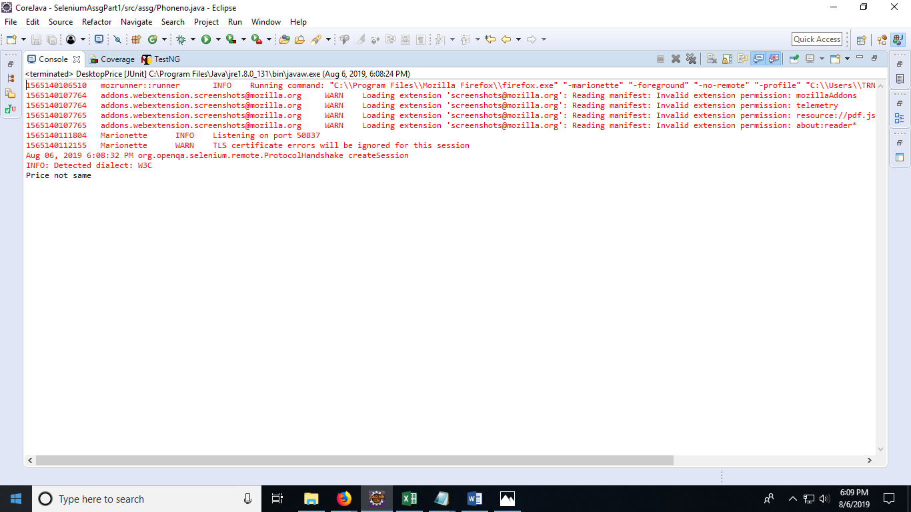

Scenario 4 output

Scenario - 5;

Count the number of elements present in MyAccount

Code:

**package** assg;

**import** **static** org.hamcrest.CoreMatchers.*is*;

**import** **static** org.hamcrest.core.IsNot.*not*;

**import** java.util.List;

**import** org.openqa.selenium.By;

**import** org.openqa.selenium.WebDriver;

**import** org.openqa.selenium.firefox.FirefoxDriver;

**import** org.openqa.selenium.Dimension;

**import** org.openqa.selenium.WebElement;

**import** org.openqa.selenium.interactions.Actions;

**import** org.openqa.selenium.support.ui.ExpectedConditions;

**import** org.openqa.selenium.support.ui.Select;

**import** org.openqa.selenium.support.ui.WebDriverWait;

**import** org.openqa.selenium.JavascriptExecutor;

**import** org.junit.Before;

**import** org.junit.Test;

**import** org.openqa.selenium.Alert;

**import** org.openqa.selenium.Keys;

**public** **class** MyAccount {

**public** **static** **void** main(String args[])

{

String s= "C:\\Users\\TRNG\\Downloads\\gecko\\geckodriver.exe";

WebDriver driver;

System.*setProperty*("webdriver.gecko.driver",s);

driver = **new** FirefoxDriver();

driver.get("https://demo.opencart.com/");

driver.findElement(By.*xpath*("/html/body/nav/div/div[2]/ul/li[2]/a/span[1]")).click();

List<WebElement> L=driver.findElements(By.*tagName*("a"));

System.***out***.println("Count of no.of elements in MyAccount along with register and login "+L.size());

}

}

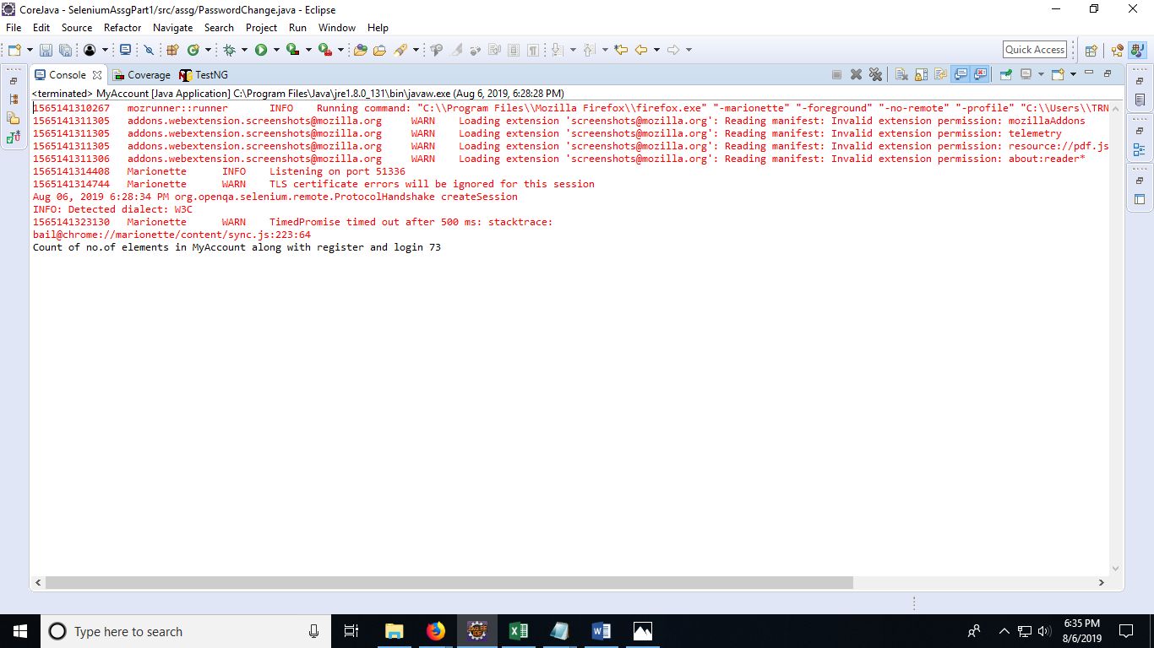

Scenario 5 output

Scenario - 6:

Verify whether the user can able to change the password.

Code:

**package** assg;

**import** org.openqa.selenium.By;

**import** org.openqa.selenium.WebDriver;

**import** org.openqa.selenium.firefox.FirefoxDriver;

**public** **class** PasswordChange {

**public** **static** **void** main(String args[])

{

String s= "C:\\Users\\TRNG\\Downloads\\gecko\\geckodriver.exe";

WebDriver driver;

System.*setProperty*("webdriver.gecko.driver",s);

driver = **new** FirefoxDriver();

driver.get("https://demo.opencart.com/index.php?route=account/login");

driver.findElement(By.*id*("input-email")).click();

driver.findElement(By.*id*("input-email")).sendKeys("gayathrisiri1314@gmail.com");

//login functionality

driver.findElement(By.*id*("input-password")).click();

driver.findElement(By.*id*("input-password")).sendKeys("ssssssss");

driver.findElement(By.*xpath*("/html/body/div[2]/div/div/div/div[2]/div/form/input")).click();

// password change

driver.findElement(By.*xpath*("/html/body/div[2]/div/aside/div/a[3]")).click();

driver.findElement(By.*xpath*("//*[@id=\"input-password\"]")).sendKeys("gggggggg");

driver.findElement(By.*xpath*("//*[@id=\"input-confirm\"]")).sendKeys("gggggggg");

driver.findElement(By.*xpath*("/html/body/div[2]/div/div/form/div/div[2]/input")).click();

System.***out***.println("password changed successfully");

}

}

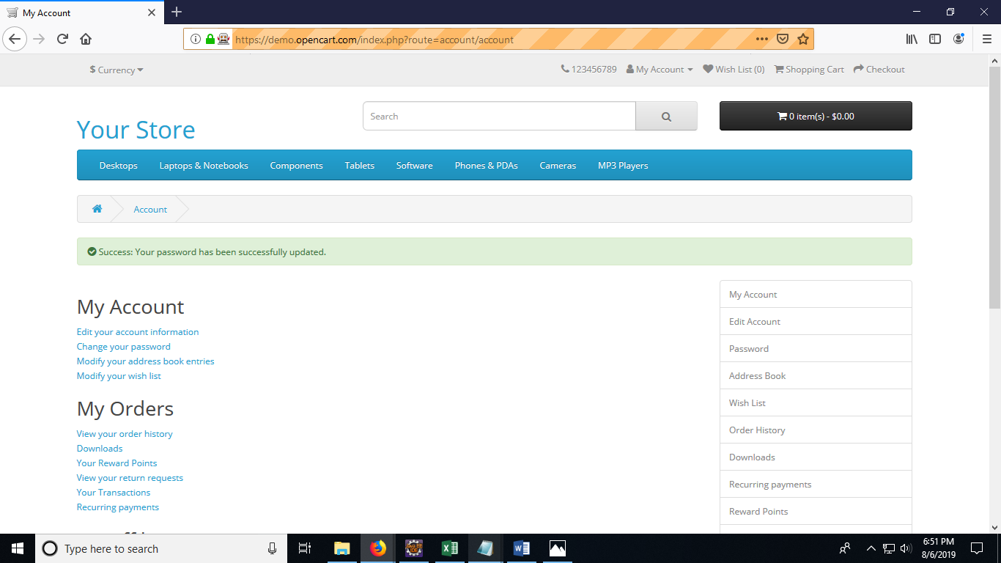

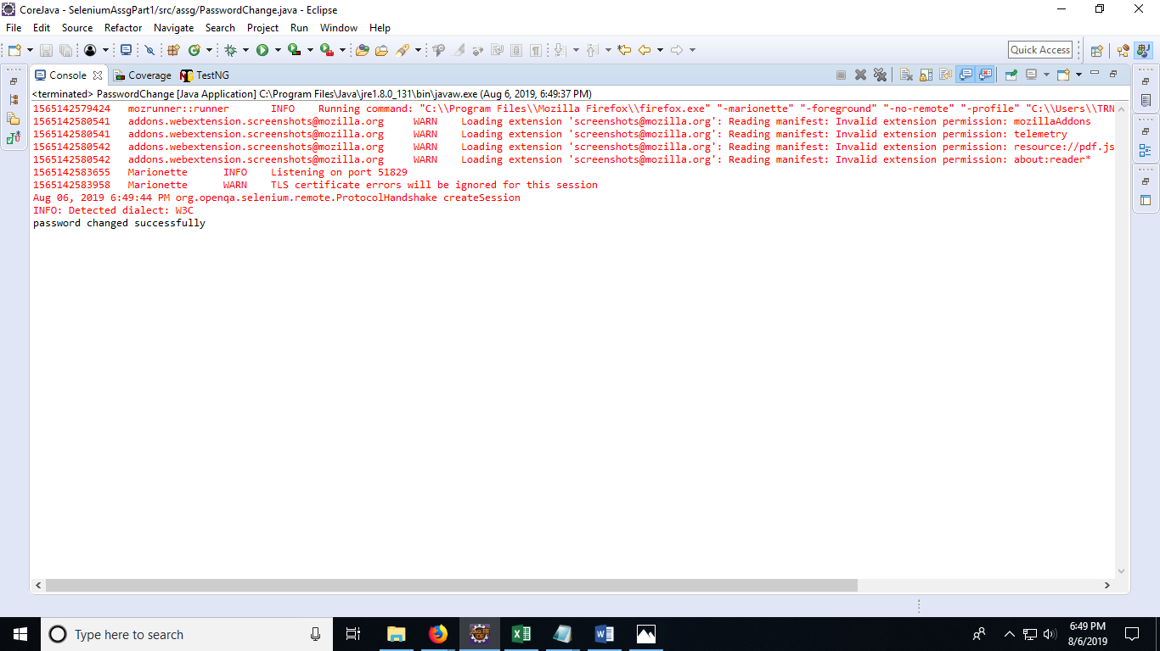

Scenario 6 outputs